Experiment #4 / Unit 5
The Acetylene-Powered Bucket Launch
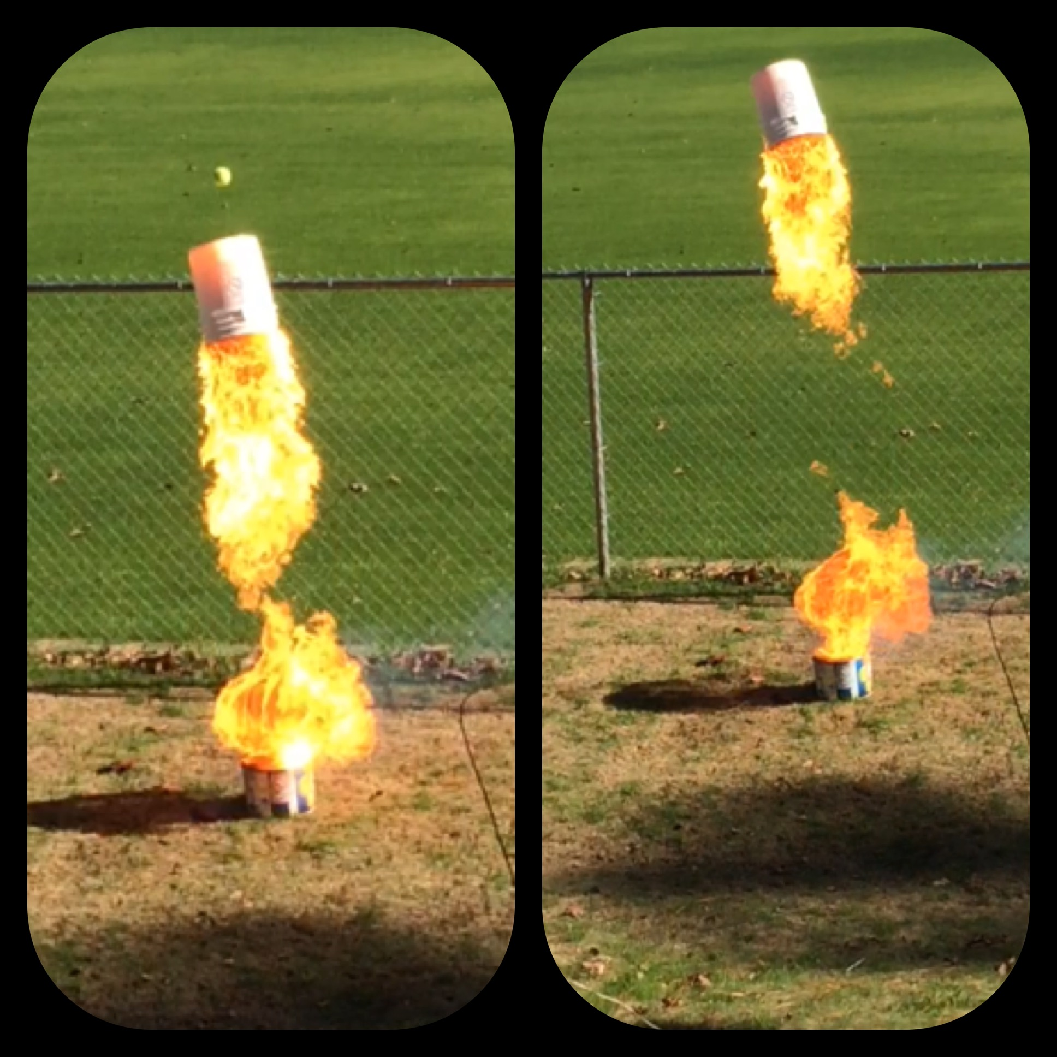

Introduction:
In this experiment, we will try to convert the potential energy of a molecule into observable work – causing a large bucket to fly into the sky! Acetylene is a molecule with a lot of potential energy. That energy can be converted into different forms and transferred to other substances if we do a suitable chemical reaction. In this case, we will do the same reaction that welders carry out to make a steel-cutting torch – combustion. We will actually carry out two different reactions inside the bucket. The first reaction will involve calcium carbide (CaC₂) and water molecules. This reaction will produce acetylene gas. The second reaction will involve acetylene and oxygen. In this experiment, we will be able to see (and use) most of the principles that we have studied so far this year.

- Atomic structure – What is the structure of the atoms involved? Are they more stable as a result of the compounds that they have formed? Have they reached a noble gas configuration? Have they transferred electrons to become ions or are they sharing electrons?
- Bonding & Structural Theory - What kind of bonds have they engaged in? Have they followed the octet rule? Are they sharing more than one pair of electrons? What is the potential energy of these bonds? Are they sharing equally or might some partial charges exist? Are the partial charges allowing them to attract their neighbors?
- Balanced Equations, the Mole Counting Unit, & Stoichiometry – How do we describe what will happen in symbols? Is this a redox reaction? What are the products? What are the quantitative relationships between the reactants and products? How many molecules will I need to react? How much of the products will be produced?
- Thermodynamics – How much potential energy do these reactants possess? Will the products have more (endo) or less (exo) energy? What is the value for the enthalpy change of this reaction? Based on how much reactants we used, how much heat will be given to or absorbed from the surroundings? Do the products have more or less disorder than the reactants? How much free energy is available from this reaction for useful work? Will this reaction be spontaneous?
- Kinetics – What can I do to make this reaction go faster? Should I use large chunks of reactants or powder? If I run the reaction outside on a winter day, will this affect my reaction? What about water temperature?
- Gas Laws – What volume of acetylene gas will be produced? What volume of oxygen will I need to carry out a good reaction? What will be the pressure produced by the gases? If the gases heat up, what will happen? How do gases create enough force to move objects?
- Aqueous Chemistry – What will be the pH of solution remaining after the acetylene is produced?

Pre-lab Predictive Work:
This is a chance to appreciate how powerful a balanced equation and a good counting unit can be. We can predict what nature is going to do before it happens. What we want to predict is how much calcium carbide we will need to get a good explosion, how high the bucket should travel, and how the temperature and pH of the water will be affected. To do this, we will have to have a major brainstorming session.

Predictions:
- Balanced equations
- Predict how much acetylene will be needed.
- Predict how much calcium carbide will be needed.
- How much free energy will be available from the burning acetylene?
- How high could the bucket fly?
- Predict the final temperature of the water.
- Predict the final pH of the water.

The following materials will be needed:

- solid calcium carbide
- dihydrogen monoxide
- launch bucket & base bucket (fuse hole, no rim)
- fuse, scissors, & lighter
- stopwatch

Procedure:
- Pre-mass several trials worth of calcium carbide into plastic baggies.
- Find an open field near school.
- Two large plastic buckets are required. We have acquired ours from the school cafeteria…..they held pickles. Using a hacksaw, the rim of one bucket is removed. This is the base bucket. This holds the water. A fuse hole is melted just above the water line. When ready, the launch bucket is inverted and squeezed down onto the base bucket.
- Add the water to the base bucket.
- Insert the fuse into the fuse hole.
- Note: we will set-up a simultaneous copy of the reaction (without the ignition and launch) to run temperature and pH tests.
- Add the calcium carbide and quickly cover the base bucket with the launch bucket. Squeeze this down tightly……we sit on it. Gases will escape the fuse hole.
- Begin the countdown. This is the part that we haven't perfected yet. How much wait time to allow the reaction to produce acetylene? We have tried many scenarios – 2 min. wait time for approx. 20 rocks of carbide, 3-5 min. wait time for approx. 8 rocks of carbide, 10 min. wait time for one 8 g rock of carbide, etc.
- Light the fuse and retreat to a safe distance.
- Measure the flight time of the bucket.

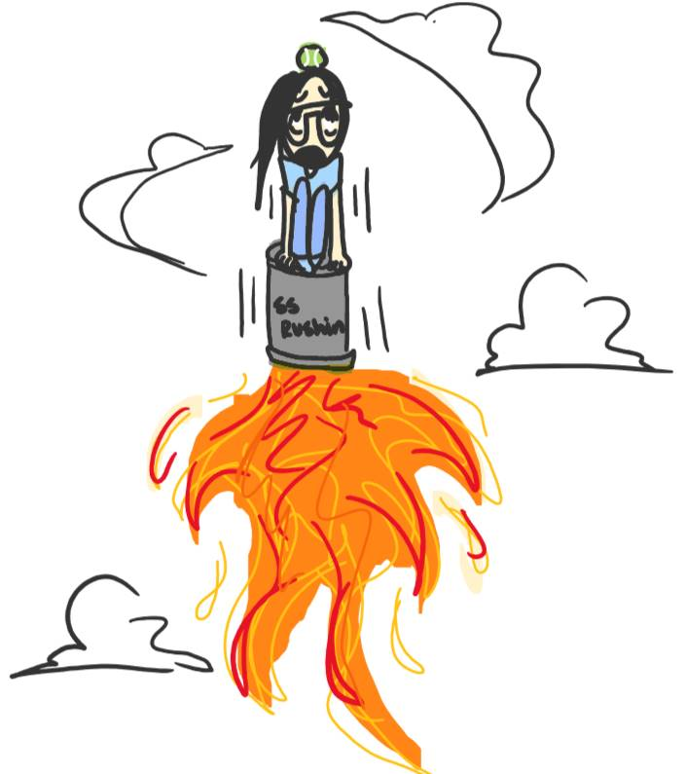
Data:
- mass of calcium carbide
- the volume of the water in the base bucket
- time that launch bucket was airborne
- observations
- temperature graph for reaction
- pH graph for reaction

Calculations and Questions:
- Draw the Lewis structure of the acetylene and ethane molecules. How do the bond lengths and bond energies compare for the carbon-carbon bond in these two molecules?
- What is the potential energy of acetylene as calculated from its bond energies? What is the shape of this molecule? Draw the locations of any partial charges and dipoles. Is this molecule polar or non-polar?
- Account for the natural state of acetylene. Describe what would happen to a collection of these molecules if they got really cold.
- At what temperature would you finally achieve an organized crystal of acetylene?
- Balance the combustion of acetylene using the redox method. Which atom is reduced/oxidized? What compound serves as the oxidizing/reducing agent?
- For both reactions, calculate:
- the enthalpy change
- the entropy change
- the free energy change. Which reaction is capable of doing more work?
- Will the reactions be spontaneous at all temperatures? If not, at what temperature will it lose spontaneity?
- Write a balanced equation for the combustion of acetylene where there is a Lewis structure for each molecule reacted and produced. Recalculate the enthalpy change for the combustion reaction using bond energies.
- Compare the final temperature predicted to the actual.
- Compare the final pH predicted to the actual.
- Describe how the bucket is able to fly into the sky against the force of gravity.
- How high did the bucket fly? The bucket did not fly as high as predicted. Why not?
- Explain how the particle size of calcium carbide and the temperature of the water would affect the rate at which the acetylene was produced.

Lab Report #5.4 (75 pts):
- title page (1 pt)
- abstract (6 pts)
- procedure sheet (1 pt)
- pre-lab predictions (20 pts)
- data and graphs (7 pts)
- calculations and questions (40 pts)

