Experiment #2.3: What Happens When Sodium
Goes Swimming in a Trashcan

Introduction:
In this experiment, we will study the series of reactions that begin when sodium metal is placed in water. These reactions will give us a bountiful opportunity to apply the principles of thermodynamics that we have been studying and make some predictions about the behavior of the atoms involved. This reaction can be quite violent and dangerous especially using the quantity of sodium (25-35 g) that we will use. The experimental set-up will allow us to observe the reactions safely and to collect data that we can compare to some of our predictions.

Experimental Set-up:
A large quantity of water will be measured and placed in a small, plastic trashcan. Phenolpthalein will be added to the water. The small trashcan will be placed inside a large metal trashcan. A probe interface will be set-up to collect pH and temperature data and will be placed in the metal trashcan. The sodium metal will be massed and placed in a zip-loc bag. Two holes will be made in the bag. A hole at the top of the bag will allow us to tie the bag with kite string. A hole at the bottom will allow the other reactant to enter the bag. There is a hole in the lid of the metal trashcan. This will allow us to slip the kite string through the lid and hold the sodium bag above the water while the lid of the metal can is closed. We can back up to a safe distance and cut the string when we are ready.

Experimental Diagram:
Chemistry Students

Sodium

Metal

Probes

Interface

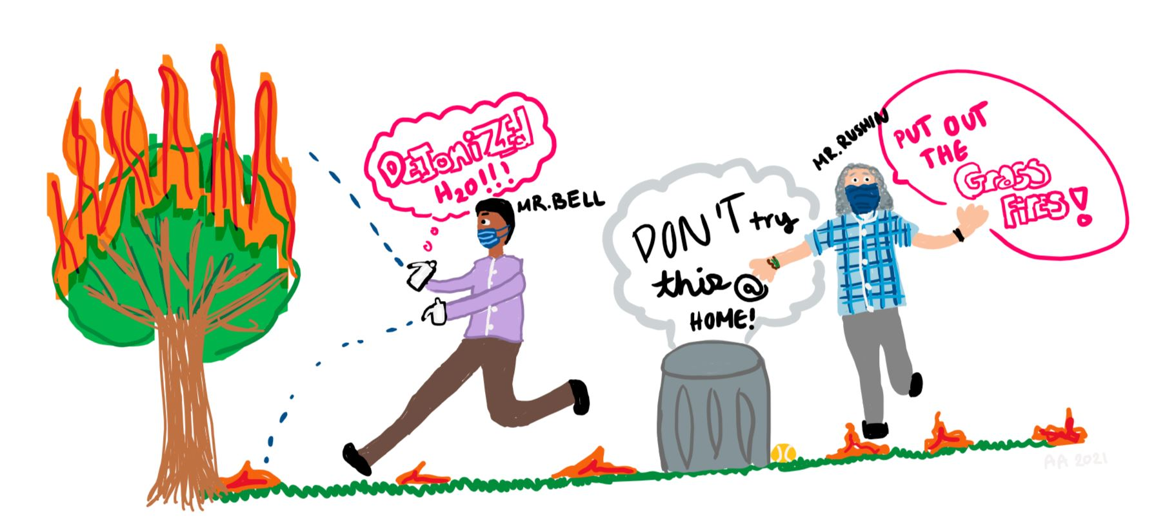

Predictions:
- Write balanced equations for all five reactions……yep, five.
- How much sodium hydroxide should be produced?
- What should the molarity of the sodium hydroxide be?
- What should the pH of the water be?
- How much hydrogen should be produced in moles and grams?
- What should be the volume of the hydrogen gas (assume STP conditions)?
- How many new water molecules could be formed from these hydrogen molecules?
- What is the standard enthalpy change for the reaction of sodium and water? How much heat should be produced from our first reaction?
- What temperature change should the water experience?
- What is the enthalpy change for the formation of new water molecules? How much heat should be produced from our hydrogen?
- Calculate the enthalpy change for the hydrogen explosion using bond energies.
- Calculate the entropy and free energy changes for the following reactions: sodium & water, hydrogen & oxygen.

Data:
- volume of the water
- initial and final temperature of the water
- initial and final pH of the water
- mass of sodium
- observations
- graphs of temperature and pH changes

Calculations and Questions:
- What was the actual ΔpH for the water?
- What temperature change did the water experience? Why is this answer different from our prediction?
- Describe what happens (before, during, and after reaction) to each atom individually when sodium reacts with water. Consider bond changes (breaking & making), electron changes, new partnerships, state changes, location changes……where are our sodiums now?......what are their possibilities?
- Comment on each of the entropy and free energy changes that you calculated. Do these values correspond with the balanced equations and what you observed outside?
- Explain the white smoke that you observed.

Lab Report #2.3: 60 pts
- title page
- abstract
- procedure sheet
- predictions
- data
- calculations and questions

